**Kubernetes**

**1)Deploy a Nginx pod**

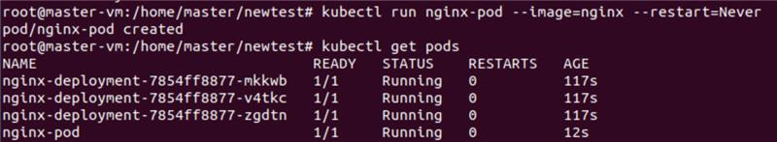

**2)Now Forward the port to access Nginx**



**3)So the port is running successfully as we can see nginx default page**

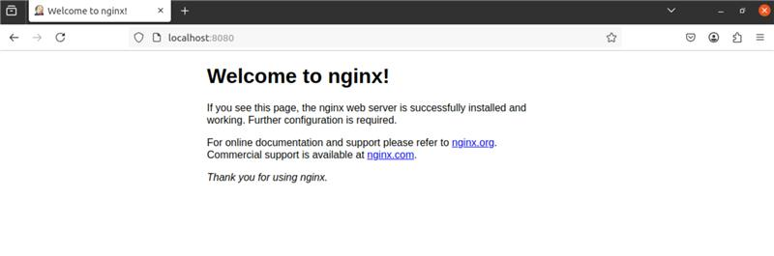

Scale the Deployment

4)create deployment.yml file with replicas

